Emergel
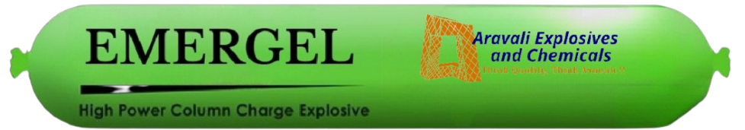

High Power Column Charge Explosive

Description & Application
Emergel is a high strength booster sensitive packaged emulsion explosives suitable for use in most types of blasting applications using medium and large diameter holes and represent the latest development in slurry explosives technology.

The product is chemically gassed and cross-linked is specifically designed for blasts in open cast mines, quarries, and construction. Superior rigid gel also ensures good handling.

Its high strength and high velocity of detonation ensures good fragmentation in hard strata and give excellent blast results in quarrying, road cutting, canal excavation and civil construction.

Product is relatively insensitive to accidental initiation due to impact, friction, and fire. Hence it is very safe during handling, transportation, storage, and usage.

Excellent water resistance allows usage in watery holes. Product has excellent fume characteristics post detonation.

Technical Properties

Nominal Density (g/cc) | 1.10 –+ 0.05
Relative Weight Strength* | 75 %
Relative Bulk Strength* | 100 %
Minimum Velocity of Detonation (Km/Sec) | 3.8
*Compared to ANFO@ 0.85 g/cc

Notes:

- REE is the Relative Effective Energy to ANFO at a density of 0.85g/cc. ANFO has an effective energy of 2.30 MJ/kg.

- VOD will depend on application including explosive density, blasthole diameter, temperature, and degree of confinement. The minimum VOD quoted is based on unconfined test firing data and calculated energy values.

Packaging
Emergel is packaged in HDPE film. Each box contains nominally 25kg of product with standard cartridge sizes and counts as follows:

Diameter mm | Nominal length mm | Nominal Mass gm | Cartridge per Box
83 | 480 | 2780 | 9
125 | 460 | 6250 | 4
Other diameter/grams combinations can be offered on request.

Recommendations for Use
- Excellent water resistance and high density allow use in wet blastholes.
- Requires Booster for reliable initiation.
- Suitable for use in ground temperatures up to 60ºC.
- During charging ensure that cartridges are charged in a continuous column in the bore hole.
- Post detonation fume characteristics of the product make it suitable for both underground and surface blasting applications, however users should ensure that adequate ventilation is provided prior to re-entry into the blast area.
- Avoid extremes of shock, heat, friction or mechanical
impact to prevent pre-mature initiation.

Emergel

High Power Premier Explosive

Storage
For the best results, store under moderate temperatures and dry conditions in a well ventilated, approved magazine.
If stored in cool, dry, well-ventilated magazine and handled properly, the shelf life of Emergel is 6 Months from the date of Manufacturing. However, exposure to hot or cold extremes may cause the product to deteriorate pre-maturely.
All regulations pertaining to the handling and use of such explosives apply.

Shipping Information:
Authorised Name
of Explosive : EMERGEL
Proper Shipping Name : EXPLOSIVE, BLASTING, TYPE E Class / Div. : 2, 0
UN No. : 0241

Disposal
The disposal of explosives material is dangerous and require special training. Methods used for safe disposal may vary from case to case and will depend upon conditions under which the operations take place. For further information please contact our representative in your area.

Aravali Explosives And Chemicals
A Kapil Sons Group Initiative
01, Talegaon Raghuji, Arvi Road,
Post – Panwadi, District – Wardha,
State – Maharashtra - 442106
+91 74698-11111, +91 95798-17934

